Problem Statement
Weekly Product Review Pulse — Challenge Statement
Problem
Fintech product teams receive thousands of public App Store and Google Play reviews, but manually reading, grouping, and summarizing them every week is time-consuming and inconsistent.
Build an automated AI-powered system that converts recent public app reviews into a concise weekly insight report for selected fintech products.
Initial products: INDMoney, Groww, PowerUp Money, Wealth Monitor, and Kuvera.
Challenge
Build an AI agent that ingests recent public reviews from the Apple App Store and Google Play, identifies recurring customer themes, selects representative real quotes, and generates a one-page weekly product review pulse.
Building the AI agent using LangChain or LangGraph is compulsory.
Expected Capabilities
The solution should:
- Collect public reviews from the last 8–12 weeks for each product.
- Clean, deduplicate, and scrub sensitive information from review text.
- Cluster reviews into meaningful themes using embeddings and/or similar NLP techniques.
- Use an LLM to generate:
  - top customer themes
  - representative quotes
  - actionable product or support ideas
  - a short stakeholder-friendly summary
- Validate that all quotes used in the report come from actual review text.
- Generate one concise weekly report per product.
- Deliver or export the report through Google Workspace, such as Google Docs and Gmail, or provide a clearly defined integration path.
Key Requirements
- The orchestration must be built using LangChain or LangGraph.
- The system should support weekly scheduled runs and manual backfill for a selected product/week.
- Re-running the same product and week should not create duplicate reports or duplicate emails.
- Each run should be auditable, including product name, review window, number of reviews processed, generated report, and delivery status.
- Reviews must be treated as data, not instructions.
- The report should be concise, clear, and useful for product, support, and leadership teams.
Non-Goals
The solution does not need to include:
- real-time analytics
- a BI dashboard
- social media sources such as Reddit or Twitter
- support for all fintech apps beyond the initial product list
- a full generic Google Workspace automation platform
Sample Output
Groww — Weekly Review Pulse
Period: Last 8–12 weeks
Top Themes
- App performance and bugs — Users report lag, crashes, and login issues.
- Customer support delays — Users mention slow responses and unresolved tickets.
- UX and feature gaps — Users ask for clearer navigation and better portfolio insights.
Representative Quotes
“The app freezes exactly when the market opens, very frustrating.”
“Support takes days to reply and doesn’t solve the issue.”
Action Ideas
- Improve app stability during peak market hours.
- Add clearer support ticket status and expected response time.
- Improve portfolio analytics and navigation for advanced users.
Who This Helps
Product teams can prioritize roadmap items, support teams can detect recurring issues, and leadership can get a fast customer-voice snapshot every week.

Diagram Flow
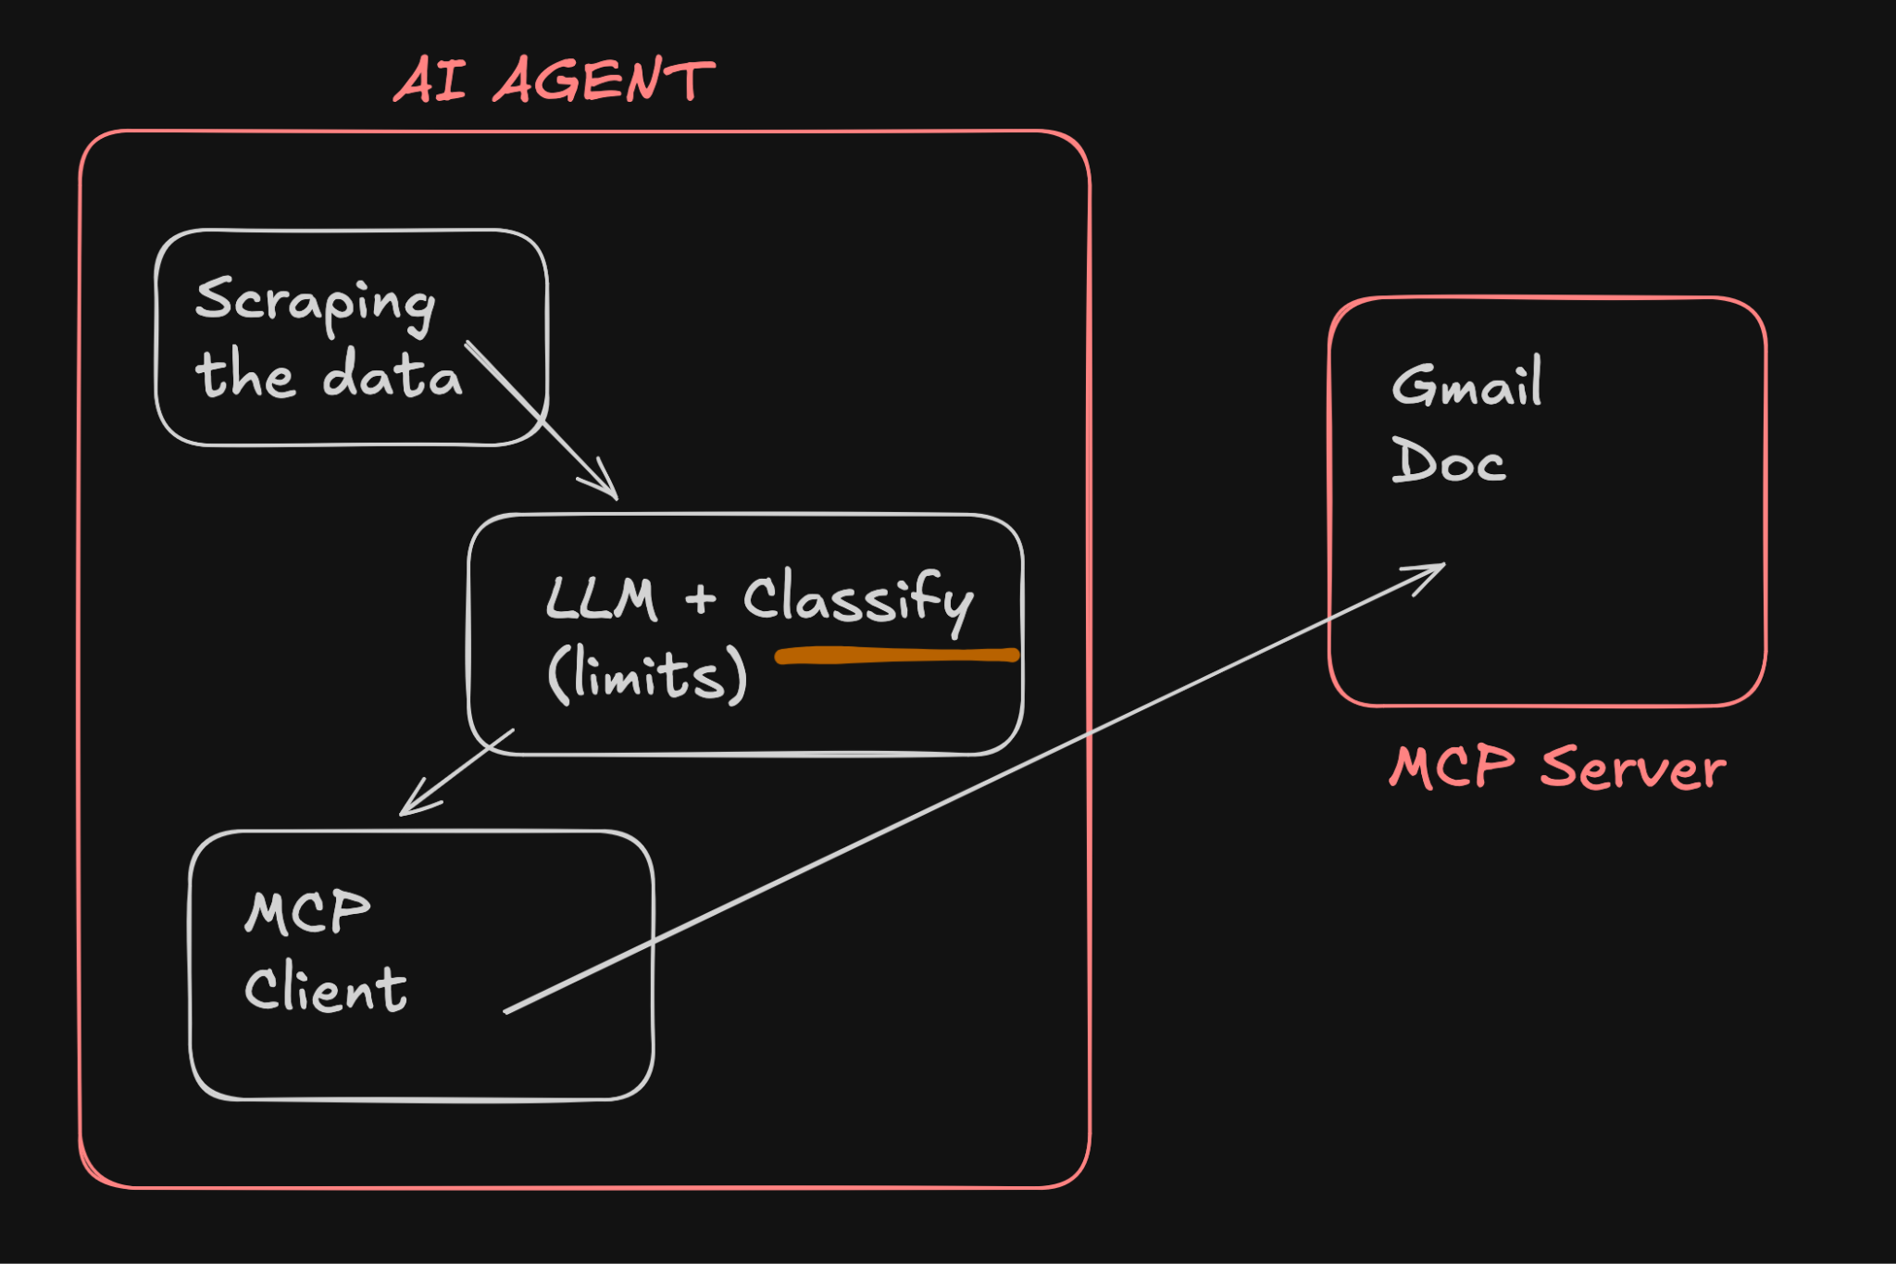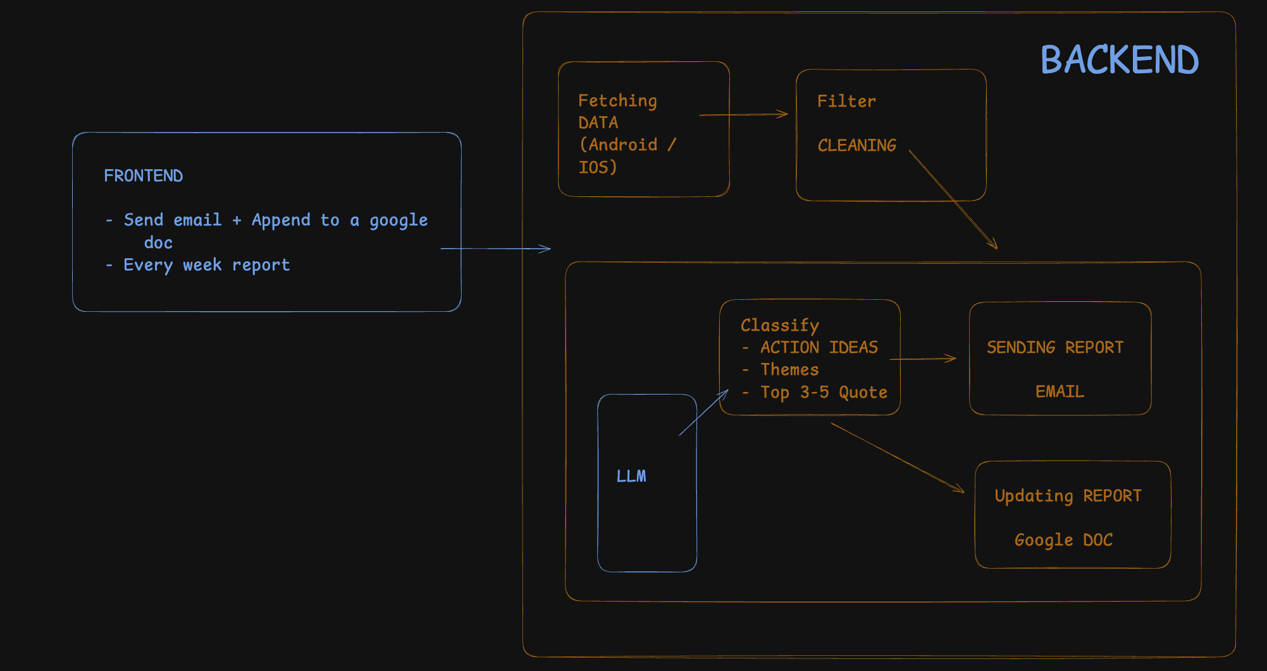

STEP
- Docs (CONTEXT)
  - problemStatement.txt
  - problemStatement.md
  - architecture.md
  - implementation-phase.md
  - edge-case.md + eval.md
- Implementation

Prompts
- Create a problemStatement.md file which stores the necessary context of @doc/problemStatement.txt
- In the @doc/problemStatement.md update the product we will use as Groww
- Generate a detailed architecture.md using the @doc/problemStatement.md
- Generate a phase-wise implementation-plan.md using @doc/architecture.md
- Generate an edge-case.md file covering all the corner scenarios using @doc/implementation-plan.md
- Implement phase1 as per the @doc/implementation-plan.md
- Rather than openAI I will be using Groq as a LLM update phase1
- Implement phase2 as per the @doc/implementation-plan.md
- Run phase2
- In phase3 we can remove all reviews which are in hindi or other language
we can remove all reviews with less than 8 words
We can remove emoji's from the reviews as well
update this in the @doc/implementation-plan.md for phase3
- Implement phase3 as per the @doc/implementation-plan.md
- Run phase3
- Implement phase4 as per the @doc/implementation-plan.md
LLM here will be Groq
- In phase5 We will use our own MCP server -
<MCP Server>
Details of this MCP server -
https://github.com/saksham20189575/mcp-server-new
Update my @doc/implementation-plan.md on phase5
- Limits of Groq for phase4 -
Llama-3.3-70b-versatile
request per minute -30
request per day - 1K
tokens per minute - 12K
tokens per day - 100K
- Based on the limits do necessary code changes for phase4
- Run phase4 and generate the report
- Implement phase5 as per the @doc/implementation-plan.md
- Doc id in .env
- Run phase5

Create MCP Server
- Prompt for MCP server →
Build me a complete MCP-style server in Python that integrates with
Google Docs and Gmail.
📁 Project Structure:
google-mcp-server/
├── server.py → FastAPI app with tool endpoints
├── auth.py → Google OAuth authentication
├── docs_tool.py → Google Docs tool (append content)
├── gmail_tool.py → Gmail tool (create draft)
├── requirements.txt → All dependencies
├── README.md → Setup and usage instructions
├── credentials.json → (NOT committed — downloaded from Google Cloud)
└── token.json → (NOT committed — auto-generated after OAuth)
⚙️ Features to Build:
1. server.py
- Use FastAPI + uvicorn
- Create two POST endpoints:
* POST /append_to_doc → accepts doc_id and content, appends text to a Google Doc
* POST /create_email_draft → accepts to, subject, body and creates a Gmail draft
- Before executing any action, print the action name and payload in the
terminal and ask: "Approve? (y/n)" — only proceed if user types y
2. auth.py
- Use Google OAuth 2.0 with these scopes:
* https://www.googleapis.com/auth/documents
* https://www.googleapis.com/auth/gmail.compose
- Load credentials from credentials.json
- Save token to token.json after first login
- If token.json exists, load it directly (skip browser login)
3. docs_tool.py
- Function: append_to_doc(doc_id: str, content: str)
- Use Go

- Open → https://console.cloud.google.com/
- Enable 2 APIs → Gmail, Docs
- Create an oauth client → Search Credentails
- 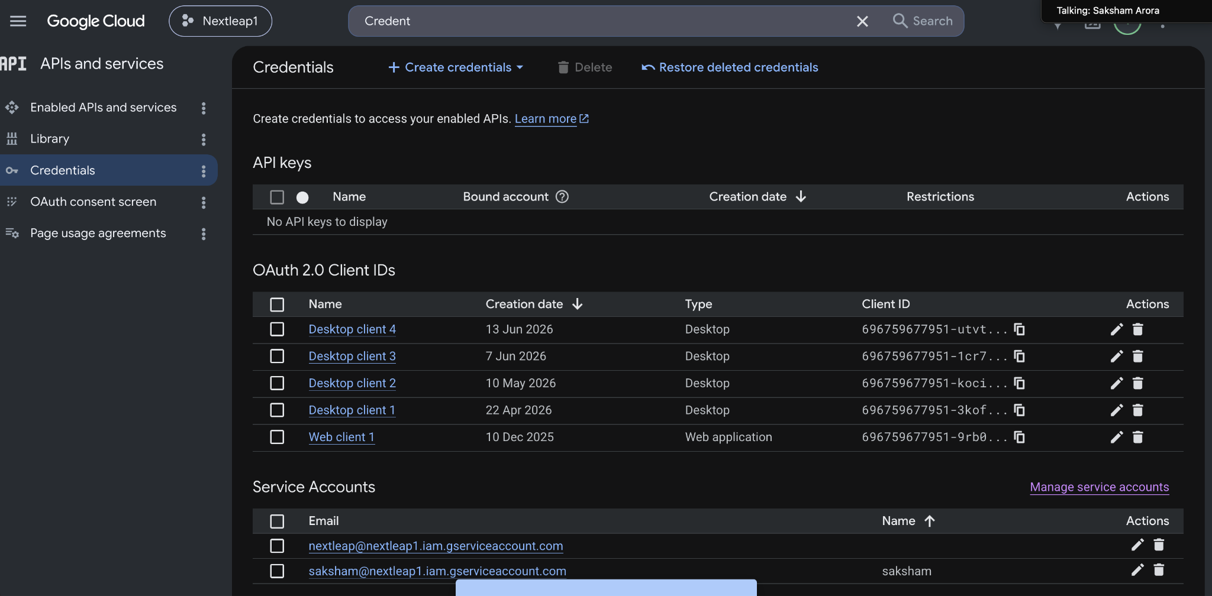

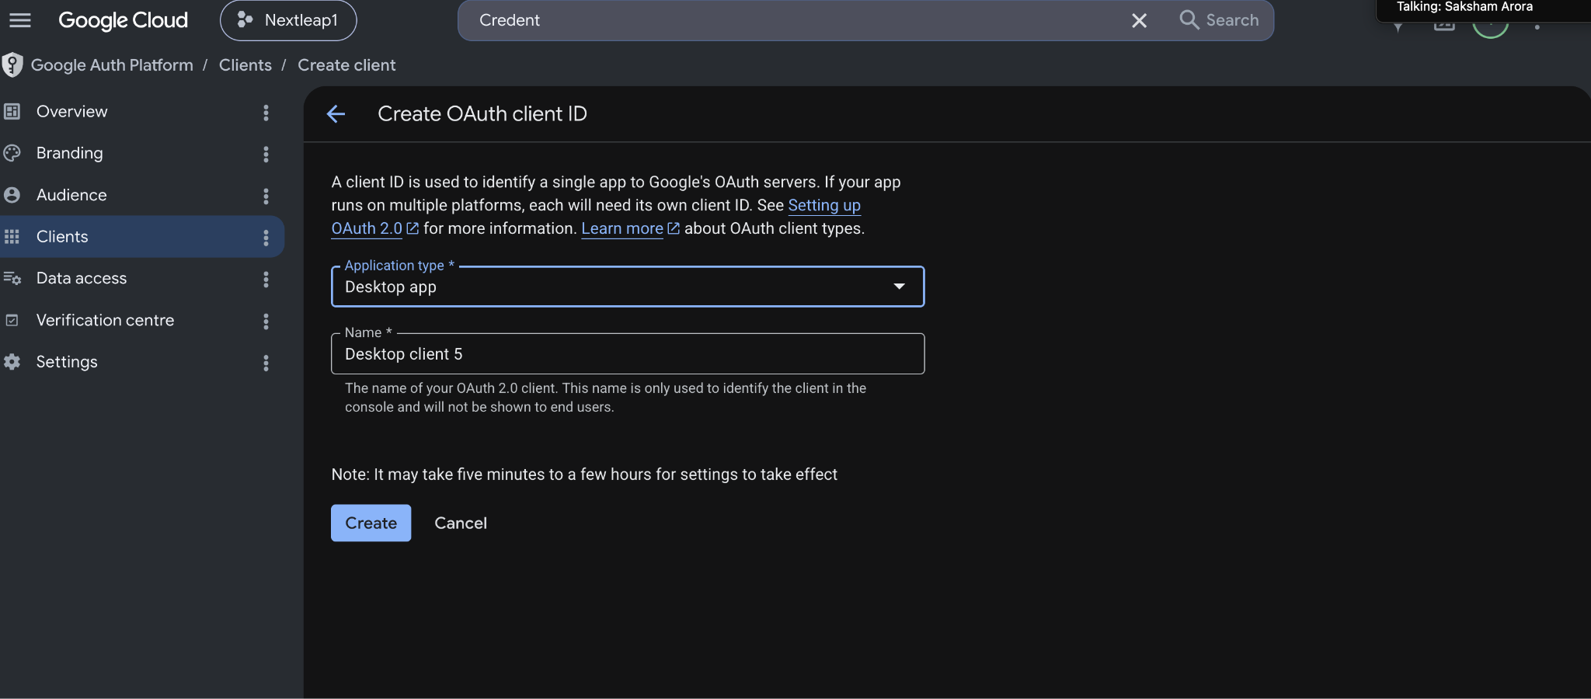

- It will give us Credential.json
- Generate → token.json
- Push MCP server on github
- Deploy MCP server → railway
- URL of MCP server →

Architecture
Weekly Product Review Pulse — Architecture
This document describes the system architecture for an AI-powered pipeline that ingests public App Store and Google Play reviews for Groww, clusters them into themes, and produces a concise weekly insight report delivered via Google Workspace.

1. Goals & Scope
Aspect | Decision
Target product | Groww (single product for v1)
Review window | Rolling 8–12 weeks per run
Output | One one-page weekly report per product per week
Orchestration | LangGraph (preferred) or LangChain
Delivery | Google Docs + Gmail (or documented integration path)
Out of scope | Real-time analytics, BI dashboard, social media, multi-product support

2. High-Level Architecture
Persistence
External Services
LangGraph Agent
Triggers
Weekly Scheduler
Manual Backfill CLI
Ingest Reviews
Clean & Dedupe
Embed & Cluster
LLM Report Generation
Quote Validation
Report Rendering
Apple App Store API / Scraper
Google Play API / Scraper
LLM Provider
Embedding Model
Google Docs API
Gmail API
Raw Reviews Store
Processed Reviews
Run Audit Log
Generated Reports
The system is organized as a directed pipeline orchestrated by a LangGraph state machine. Each node is idempotent with respect to a (product, week) run key, and every transition is recorded in an audit log.

3. Core Components
3.1 Trigger Layer
Component | Responsibility
Weekly scheduler | Cron job (e.g., Cloud Scheduler, GitHub Actions, or system cron) fires every Monday for the prior week
Backfill CLI | pulse run --product groww --week 2026-W22 for manual or historical runs
Run coordinator | Resolves run key, checks idempotency, creates audit record, invokes LangGraph graph
3.2 Review Ingestion
Collects public reviews from both stores for Groww within the configured window.
Source | Approach
Apple App Store | App Store Connect API (if credentials available) or a compliant third-party scraper/API (e.g., RSS feed, public review endpoints)
Google Play | Google Play Developer API (reviews.list) or public scrape fallback
Ingestion behavior:
- Fetch reviews posted within [week_start - 12 weeks, week_end]
- Normalize to a canonical schema (see §5)
- Store raw payloads immutably before any transformation
- Paginate until no new reviews or window boundary reached
- Tag each review with source, fetched_at, and run_id
3.3 Preprocessing Pipeline
Runs before embedding and clustering.
- Text normalization — Unicode cleanup, whitespace collapse, language detection (optional filter for English/Hindi)
- Deduplication — Hash on (source, review_id) primary; secondary fuzzy dedupe on (author_hash, text_normalized, rating, date_bucket) to catch cross-source duplicates
- PII scrubbing — Regex + NER-based removal of emails, phone numbers, account IDs, and card-like patterns
- Prompt-injection hardening — Wrap review text in delimited blocks; strip instruction-like patterns; never pass reviews as system messages (see §8)
3.4 Embedding & Clustering
Step | Detail
Embedding | Batch-embed cleaned review text via OpenAI text-embedding-3-small, Cohere, or local model
Clustering | HDBSCAN or K-Means on embeddings; target 5–10 clusters, merge/split heuristics for min cluster size
Theme labeling | LLM assigns a short human-readable label + one-line description per cluster from top TF-IDF terms and sample reviews
Ranking | Rank clusters by size, recency-weighted frequency, and average star rating (low ratings weighted higher for issue detection)
3.5 LLM Report Generation (LangGraph Node)
The generation node receives:
- Top N clusters (themes) with labels, descriptions, review counts, avg rating
- A pool of candidate quotes per cluster (3–5 verbatim snippets)
- Metadata: product name, report period, total reviews processed
LLM outputs (structured JSON via tool calling / Pydantic parser):
{
"summary": "2–3 sentence stakeholder overview",
"themes": [
{
"title": "App performance and bugs",
"description": "Users report lag, crashes, and login issues.",
"review_count": 142,
"avg_rating": 2.1
}
],
"quotes": [
{
"text": "The app freezes exactly when the market opens, very frustrating.",
"theme_title": "App performance and bugs",
"source_review_id": "abc123"
}
],
"action_ideas": [
"Improve app stability during peak market hours."
]
}

Temperature kept low (0–0.3) for consistency. System prompt defines role, output schema, and constraints (concise, actionable, no fabrication).
3.6 Quote Validation Node
A dedicated post-generation step ensures every quote in the report exists verbatim in source review text.
Check | Method
Exact match | Substring search in normalized review corpus
Fuzzy match | Levenshtein ratio ≥ 0.95 if minor whitespace/punctuation drift
Failure handling | Reject invalid quotes → re-prompt LLM with invalid quote list (max 2 retries) → fallback to next-best candidate from cluster
Audit | Log validation results per quote (pass / fail / replaced)
3.7 Report Rendering & Delivery
Render pipeline:
- Merge validated JSON into a Markdown/HTML template matching the sample output format
- Create or update a Google Doc via Google Docs API
- Send summary email via Gmail API with Doc link and inline highlights
Google Workspace integration path:
Step | API | Notes
Auth | OAuth 2.0 service account or user consent flow | Scopes: documents, gmail.send
Doc creation | Google Docs API documents.create + batchUpdate for formatting | One doc per (product, week)
Email | Gmail API users.messages.send | Subject: Groww — Weekly Review Pulse (Week of YYYY-MM-DD)
Idempotent doc | Store google_doc_id in run record; update existing doc on re-run instead of creating new
If Google credentials are unavailable in dev, export Markdown/PDF to local filesystem and log the intended Doc/Email payload (documented integration path).

4. LangGraph Orchestration
4.1 State Schema
class PulseState(TypedDict):
run_id: str
product: str # "groww"
week: str # ISO week, e.g. "2026-W22"
window_start: date
window_end: date
raw_reviews: list[Review]
cleaned_reviews: list[Review]
clusters: list[Cluster]
draft_report: ReportDraft
validated_report: ReportDraft
delivery_status: DeliveryStatus
audit: AuditRecord
errors: list[str]

4.2 Graph Topology
new_or_force
already_complete
invalid_quotes_retry
valid
failure
failure
failure
failure
max_retries
failure
check_idempotency
ingest
preprocess
embed_cluster
generate_report
validate_quotes
render_deliver
finalize_audit
handle_error
4.2 Node Responsibilities
Node | Input | Output
check_idempotency | (product, week) | Skip or continue; load prior state if partial
ingest | Window dates | Raw reviews in DB + state
preprocess | Raw reviews | Cleaned, deduped reviews
embed_cluster | Cleaned reviews | Clusters with labels
generate_report | Clusters + quotes pool | Draft report JSON
validate_quotes | Draft + review corpus | Validated report or retry signal
render_deliver | Validated report | Google Doc ID, email message ID
finalize_audit | Full state | Persisted audit record, run status
handle_error | Error context | Partial audit, alert hook
Conditional edges implement retry loops for quote validation and optional checkpoint/resume for long ingestion runs.

5. Data Model
5.1 Review (canonical)
Field | Type | Description
id | UUID | Internal ID
source | enum | app_store | google_play
source_review_id | string | Platform-native ID
product | string | groww
author_hash | string | Hashed author identifier
rating | int | 1–5 stars
title | string | Review title (App Store)
text | string | Review body
text_normalized | string | Post-cleaning text
language | string | ISO 639-1
posted_at | datetime | Review publication date
fetched_at | datetime | Ingestion timestamp
run_id | string | Ingestion run reference
5.2 Cluster
Field | Type | Description
id | UUID | Cluster ID
label | string | Theme title
description | string | One-line summary
review_ids | list | Member reviews
centroid | vector | Embedding centroid
review_count | int | Cluster size
avg_rating | float | Mean star rating
5.3 Run Audit Record
Field | Type | Description
run_id | string | Unique run identifier
product | string | groww
week | string | ISO week
window_start / window_end | date | Review window
status | enum | pending | running | completed | failed | skipped
reviews_fetched | int | Raw count
reviews_processed | int | Post-dedupe count
clusters_found | int | Cluster count
report_path | string | Local or Doc URL
google_doc_id | string | Nullable
email_message_id | string | Nullable
delivery_status | enum | pending | delivered | failed
started_at / completed_at | datetime | Timestamps
error_log | JSON | Failures and retries
Unique constraint: (product, week) on completed runs enforces idempotency.

6. End-to-End Data Flow
1. Scheduler/CLI triggers run for (groww, 2026-W22)
2. Coordinator checks audit table → no completed run → proceed
3. Ingest App Store + Play reviews for window [Mar 3 – May 26, 2026]
4. Store raw reviews → preprocess → store cleaned reviews
5. Embed reviews → cluster → label top themes
6. LLM generates structured report from cluster summaries + quote pool
7. Validator confirms each quote exists in review corpus
8. Renderer creates Google Doc, sends Gmail notification
9. Audit record marked completed with counts and delivery IDs

Average expected volume for Groww: hundreds to low thousands of reviews per 8–12 week window. Pipeline should complete within 10–20 minutes end-to-end.

7. Scheduling & Backfill
7.1 Weekly Schedule
Parameter | Value
Cadence | Every Monday 06:00 IST
Week definition | Prior calendar week (Mon–Sun)
Review window | Rolling 12 weeks ending on week_end
Concurrency | Single run at a time per product
7.2 Manual Backfill
# Run for a specific week (idempotent)
python -m pulse run --product groww --week 2026-W18

# Force re-process (updates existing doc, no duplicate email)
python -m pulse run --product groww --week 2026-W18 --force

Backfill supports arbitrary historical weeks as long as review data is available from store APIs.

8. Security & Safety
8.1 Reviews as Data, Not Instructions
Public reviews may contain adversarial or prompt-injection text. Mitigations:
Control | Implementation
Role separation | Reviews only in user/human message blocks, never in system prompt
Delimiters | Wrap each review: <review id="...">...</review>
Sanitization | Strip common injection phrases; truncate reviews > 2,000 chars
Output grounding | Quote validation ensures LLM cannot invent customer quotes
Structured output | Pydantic schema + tool calling reduces free-form hallucination
8.2 Secrets & PII
- API keys (LLM, Google, store APIs) in environment variables or secret manager
- PII scrubbed before embedding and before LLM context assembly
- Audit logs store quote text but not raw author identifiers
- Google OAuth tokens stored encrypted, rotated on schedule

9. Idempotency Strategy
Layer | Mechanism
Run level | Unique (product, week) constraint; status completed → skip unless --force
Ingestion | Upsert on (source, source_review_id)
Report | Update existing Google Doc by stored google_doc_id
Email | Track email_sent_for_run_id; suppress resend unless --force-resend
LangGraph | Checkpoint state to SQLite/Postgres; resume from last successful node
Re-running the same week with --force re-processes reviews and updates the existing Doc rather than creating duplicates.

10. Technology Stack (Recommended)
Layer | Choice | Rationale
Language | Python 3.11+ | LangChain/LangGraph ecosystem
Orchestration | LangGraph | Stateful graph, retries, checkpointing
LLM | OpenAI GPT-4o / GPT-4o-mini | Structured output, cost/quality balance
Embeddings | OpenAI text-embedding-3-small | Quality + simplicity
Clustering | scikit-learn (HDBSCAN/K-Means) | Mature, no extra infra
Database | SQLite (dev) / PostgreSQL (prod) | Reviews, runs, checkpoints
Scheduler | cron / GitHub Actions / Cloud Scheduler | Simple weekly trigger
Google APIs | google-api-python-client | Docs + Gmail
Config | pydantic-settings + .env | Typed configuration
Testing | pytest | Unit + integration with mocked APIs

11. Project Structure
m3_5/
├── doc/
│ ├── problemStatement.md
│ └── architecture.md
├── src/
│ └── pulse/
│ ├── __init__.py
│ ├── cli.py # Backfill & manual run entrypoint
│ ├── config.py # Settings & Groww app IDs
│ ├── graph/
│ │ ├── state.py # PulseState definition
│ │ ├── nodes.py # LangGraph node implementations
│ │ └── workflow.py # Graph assembly & compilation
│ ├── ingestion/
│ │ ├── app_store.py
│ │ └── google_play.py
│ ├── processing/
│ │ ├── clean.py
│ │ ├── dedupe.py
│ │ └── pii.py
│ ├── clustering/
│ │ ├── embed.py
│ │ └── cluster.py
│ ├── generation/
│ │ ├── prompts.py
│ │ ├── report.py
│ │ └── validate_quotes.py
│ ├── delivery/
│ │ ├── google_docs.py
│ │ └── gmail.py
│ ├── models/
│ │ ├── review.py
│ │ ├── cluster.py
│ │ └── audit.py
│ └── storage/
│ └── db.py
├── templates/
│ └── weekly_pulse.md.j2 # Report template
├── tests/
├── pyproject.toml
└── .env.example

12. Observability & Auditability
Every run produces a structured audit entry satisfying the problem statement requirements:
- Product name (groww)
- Review window (start/end dates)
- Number of reviews fetched and processed
- Generated report (Doc URL or local path)
- Delivery status (Doc created, email sent, errors)
Additional operational logging:
- Per-node latency in LangGraph
- LLM token usage and cost estimate
- Quote validation pass/fail counts
- Alert on run failure (email/Slack webhook optional)

13. Failure Modes & Recovery
Failure | Detection | Recovery
Store API rate limit | HTTP 429 | Exponential backoff, resume ingestion
Empty review set | Zero reviews in window | Complete run with "insufficient data" report
LLM timeout | API error | Retry with smaller context batch
Invalid quotes | Validation node | Re-prompt (max 2x), then substitute from pool
Google API failure | HTTP 4xx/5xx | Save local Markdown, mark delivery failed, retry delivery node
Partial run crash | Checkpoint | Resume LangGraph from last checkpoint

14. Report Output Format
The rendered report follows the sample structure from the problem statement:
- Header — Product name, period, total reviews analyzed
- Executive summary — 2–3 sentences for leadership
- Top themes — Ranked list with title, description, review count
- Representative quotes — 2–3 verbatim quotes per top theme (validated)
- Action ideas — 3–5 concrete product/support recommendations
- Metadata footer — Run ID, generation timestamp, sources breakdown
Target length: one page (~500–800 words).

15. Configuration (Groww)
Setting | Example
PRODUCT_NAME | Groww
APP_STORE_APP_ID | <groww-ios-app-id>
GOOGLE_PLAY_PACKAGE | com.nextbillion.groww
REVIEW_WINDOW_WEEKS | 12
TOP_THEMES_COUNT | 5
QUOTES_PER_THEME | 2
REPORT_RECIPIENTS | product-team@example.com
GOOGLE_DOC_FOLDER_ID | <shared-drive-folder>

16. Implementation Phases
Phase | Deliverable | Duration (est.)
P1 — Foundation | Project scaffold, data models, DB, audit log, CLI skeleton | 2–3 days
P2 — Ingestion | App Store + Play fetchers, raw storage, Groww config | 2–3 days
P3 — Processing | Clean, dedupe, PII scrub, embed, cluster | 2–3 days
P4 — Agent | LangGraph workflow, LLM generation, quote validation | 3–4 days
P5 — Delivery | Google Docs + Gmail integration, report template | 2–3 days
P6 — Ops | Scheduler, idempotency hardening, tests, docs | 2–3 days

17. Open Decisions
Decision | Options | Recommendation
App Store access | Official API vs. third-party scraper | Prefer official; document scraper fallback
Cluster count | Fixed K vs. HDBSCAN auto | HDBSCAN with min cluster size = 5
Email vs. Doc-only | Both vs. Doc with link share | Both per requirements
Database | SQLite vs. Postgres | SQLite for dev; Postgres if deployed
LLM model | GPT-4o vs. GPT-4o-mini | 4o-mini for clustering labels; 4o for final report
These can be finalized during implementation without changing the overall architecture.

